**E Commerce**



**ECOMMERCE**

CONTENTS

Introduction …………………………………………………………………………………………

Acknowledgment………………………………………………………………………………….

Requirements……………………………………………………………………………………….

E-Project Analysis…………………………………………………………………………………..

User Guide……………………………………………………………………………………………

Coding………………………………………………………………………………………………….

**SUBMITED BY**

* **MUHAMMAD REHAN**
* **M.BILAL UBAIDULLAH**
* **MAIRAJ UD DIN**
* **SHAYAN**

Of batch **PR2-202207G** have successfully completed the given task for the topic

**FACULTY: SIR FAIZ**

SEMESTER CPISM

APTECH LEARNING SHAHRAH-E-FAISAL

**INTRODUCTION**

The thirst for learning, upgrading technical skills and applying the concepts in rea life environment at a fast pace is what the industry demands from IT professionals today. However busy work schedules, far-flung locations, unavailability of convenient time-slots pose as major barriers when it comes to applying the concepts into realism. And hence the need to look out for alternative means of implementation in the form of laddered approach. The above truly pose as constraints especially for our students too! With their busy schedules, it is indeed difficult for our students to keep up with the genuine and constant need for integrated application which can be seen live especially so in the field of IT education where technology can change on the spur of a moment. Well, technology does come to our rescue at such times!!Keeping the above in mind and in tune with our constant endeavour to use Technology in our training model, we at Aptech have thought of revolutionizing the way our students learn and implement the concepts using tools themselves by providing a live and synchronous e-Project learning environment!

**ACKNOWLEDGE**

The thirst for learning, upgrading technical skills and applying the concepts in real life environment at a fast pace is what the industry demands from IT professionals today. However busy work schedules, far-flung locations, unavailability of convenient time-slots pose as major barriers when it comes to applying the concepts into realism. And hence the need to look out for alternative means of implementation in the form of laddered approach. The above truly pose as constraints especially for our students too! With their busy schedules, it is indeed difficult for our students to keep up with the genuine and constant need for integrated application which can be seen live especially so in the field of IT education where technology can change on the spur of a moment. Well, technology does come to our rescue at such times!! Keeping the above in mind and in tune with our constant endeavour to use technology in our training model, we at Aptech have thought of revolutionizing the way our students learn and implement the concepts using tools themselves by providing a live and synchronous e-Project learning environment!



**WHAT IS THIS E-PROJECT?**

e-Project is a step-by-step learning environment that closely simulates the classroom and Lab based learning environment into actual implementation. It is a project implementation at your fingertips!! An electronic, live juncture on the machine that allows you to

* Practice step by step i.e. laddered approach.
* Build a larger more robust application.
* Usage of certain utilities in applications designed by user.
* Single program to unified code leading to a complete application.
* Learn implementation of concepts in a phased manner.
* Enhance skills and add value.
* Work on real life projects.
* Give a real life scenario and help to create applications more complicated and useful.
* Mentoring through email support.

**OBJECTIVE OF THIS EPROJECT**

The Objective of this program is to give a sample project to work on real life projects. These applications help you build a larger more robust application.

The objective is not to teach you JavaScript/Dreamweaver but to provide you with a real life scenario and help you create basic applications using the tools.

You can revise the chapters before you start with the project.

This project is meant for students who have completed the module of HTML5.

These programs should be done in the Lab sessions with assistance of the faculty if required.

It is very essential that a student has a clear understanding of the subject. Students should go through the project and solve the assignments as per requirements given.

Kindly get back to eProjects Team in case of any doubts regarding the application or its objectives.

**REQUIRMENTS**

The Web site is to be created based on the following requirements.

1. There should be detailed information about Products Brands

2. The site should also include the details mentioned below in relation to the

Jandga Mall

a. Home

b. Categorize

c. Detaild

d. About our team

e. Contact

3. Various records related to it should also be made available.

1) The site should also provide the details of groups/organizations/clubs with their location should be displayed using GeoLocation API (eg. GoogleMaps) that arrange mountaineering to various locations in different areas across the globe Users should also be able to see various success stories of organized camps.

4. There should be a gallery section where informative /related videos and pictures

5. There should be a separate section for the material on latest developments in the field.

6. Also there should be general guidelines.

7. Also each link must be properly hyperlinked; images must be used wherever

necessary.

**PROJECT ANALYSIS**

|  |  |
| --- | --- |
| NAME | ENROLLMENT NO |
| Muhammad Rehan | Student 1403513 |
| M.Bilal Ubaidullah | Student 1405240 |
| Mairaj ud Din | Student 1408165 |
| Shayan | Student 1403385 |
| TEACHER: SIR FAIZ | BATCH CODE:PR2-202207G |

|  |  |  |  |  |  |  |  |
| --- | --- | --- | --- | --- | --- | --- | --- |
| NAME | HOME  PAGE | CATEGORIZE  PAGE | GALERY PAGE | ABOUT US  PAGE | DETAIL  PAGE | CONTACT US  PAGE | DOCUME  NTATION |
| Muhammad Rehan |  |  |  |  |  |  |  |
| M.Bilal Ubaidullah |  |  |  |  |  |  |  |
| Mairaj ud Din |  |  |  |  |  |  |  |
| Shayan |  |  |  |  |  |  |  |

**JANDGA MALL ECOMMERCE**



This is a Ecommerce based Website. Its purpose is to purchase online products.

HOME



* This is the home page with three sliders when user open the website .

GALLERY

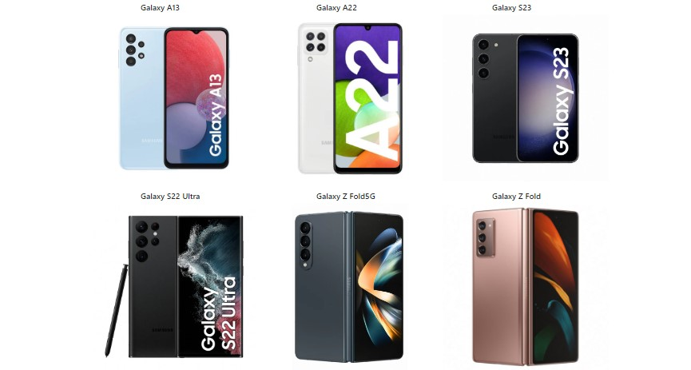

**Usage of navbar and footer:**

Navigation bars and footers are the basic need of a website now a days so to fulfill this particular requirement we have designed navbar and footer in such a way that you can easily navigate on our website without any problem more information is given below:

Navbar:

Our navbar contains five links form which ONE of them shows a drop-down menu. Dropdown menu is a categorize of Mobile Brands which people want to purchase.

images are attached below for better understanding:

Footer:

Our footer is divided into four parts **About Us, links , quick links contact**  quick links are hyperlinked from where you can navigate from one page to another page .And also you can connect with us on

Social media

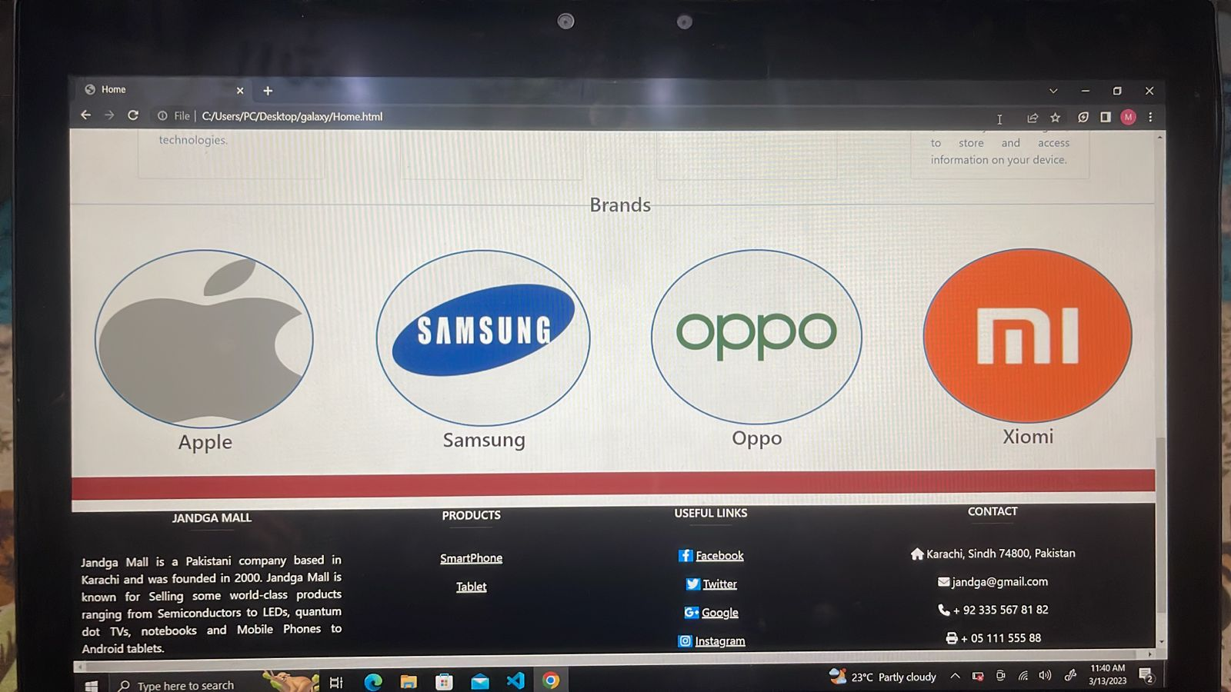

**NAVBAR-LINKS**

All the links on navbar are properly hyperlinked

There is the detailed information about:

a. Home

b. Categorize

c. About US

d. Contact Us

e. Detail Page (Of our brands)

**Home Page Source Code:**

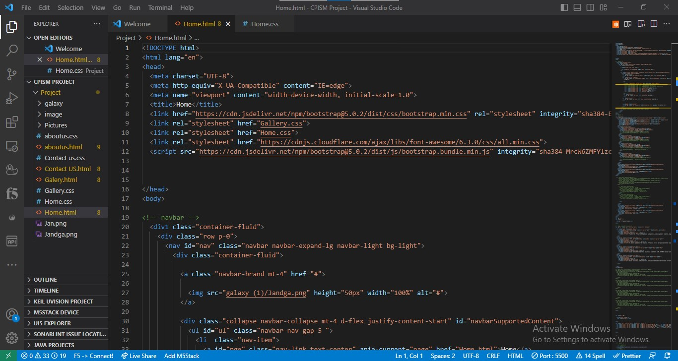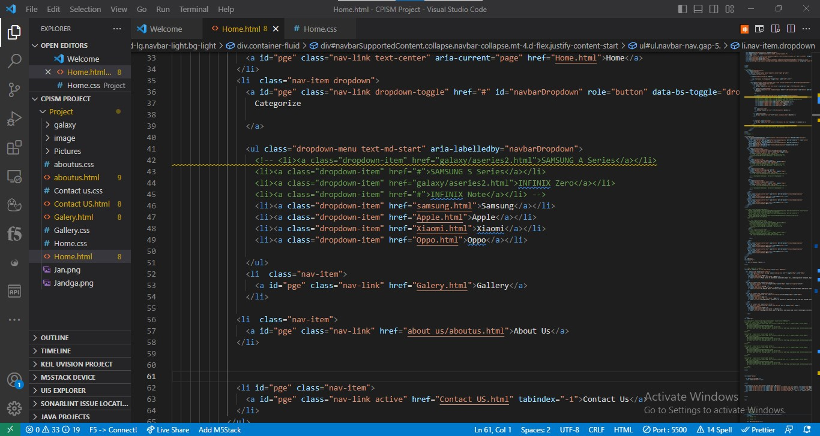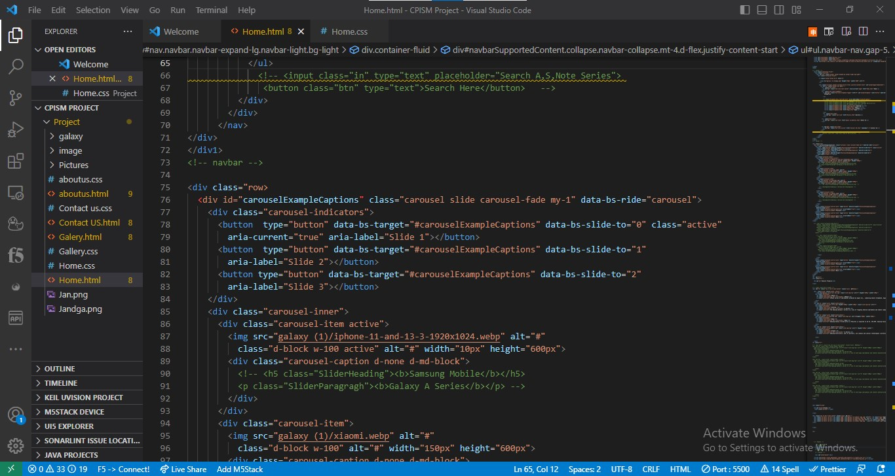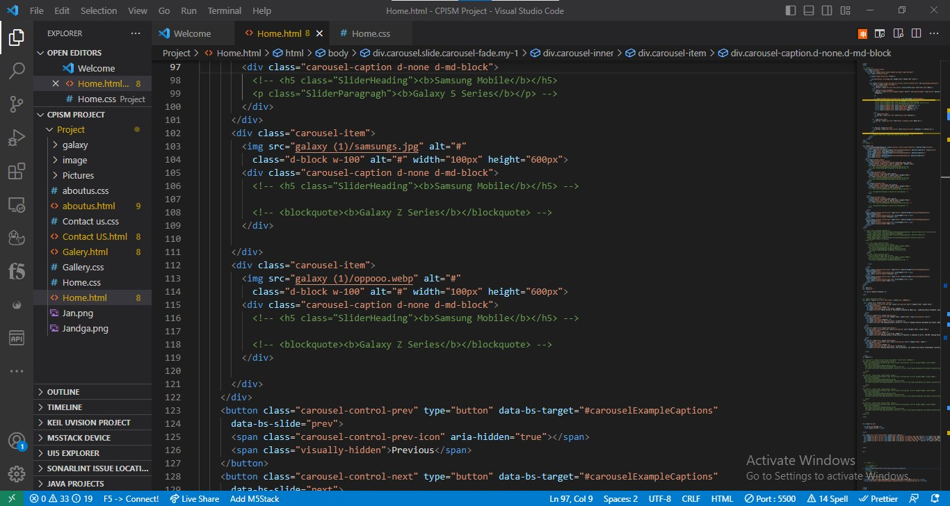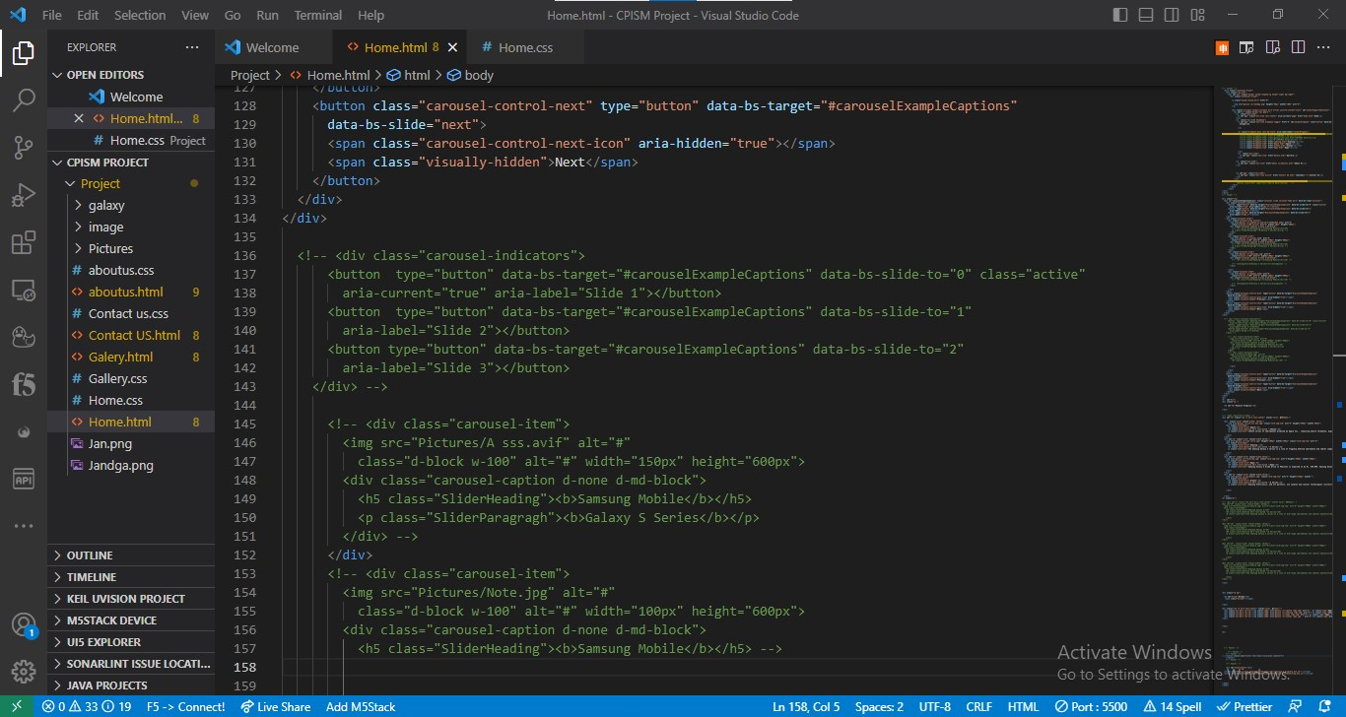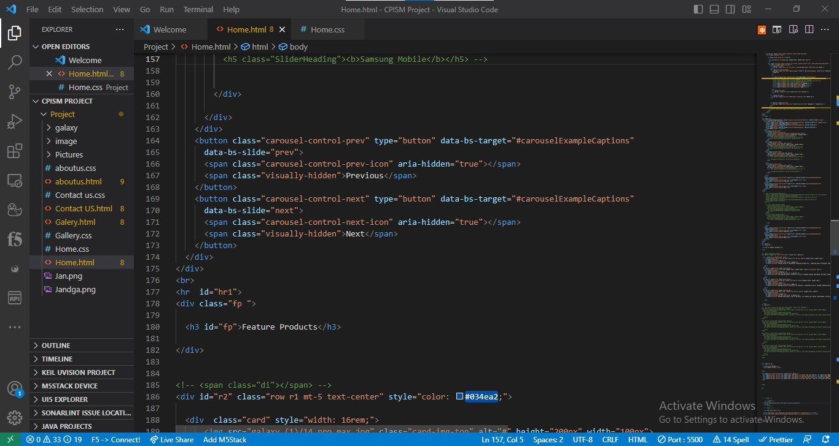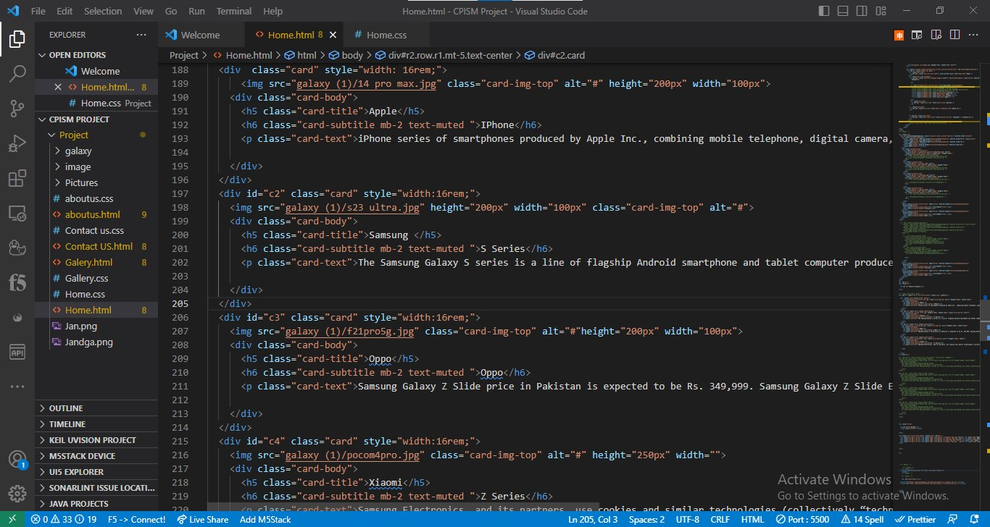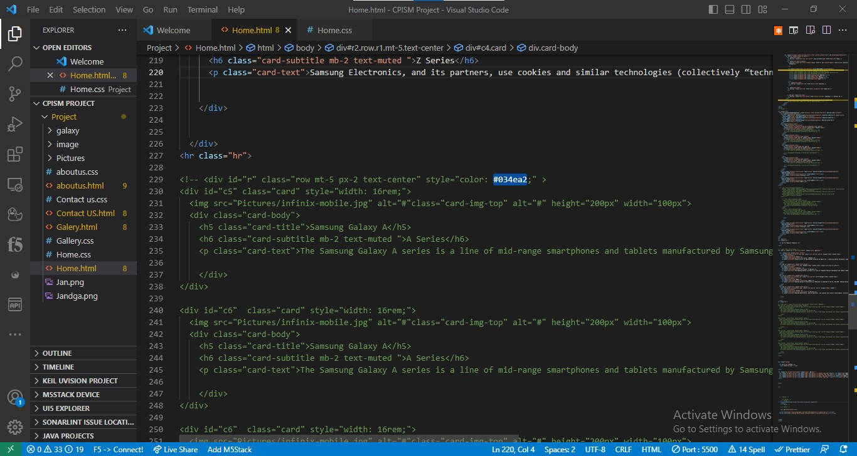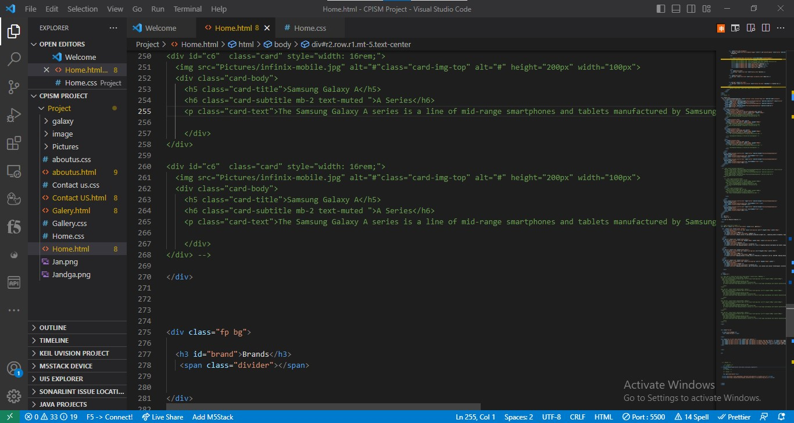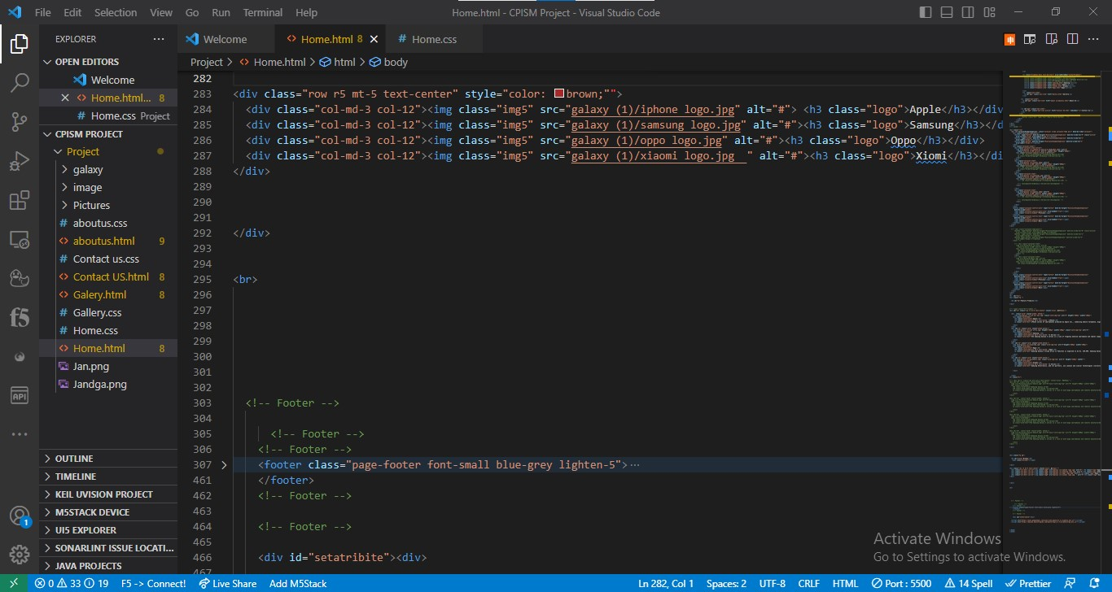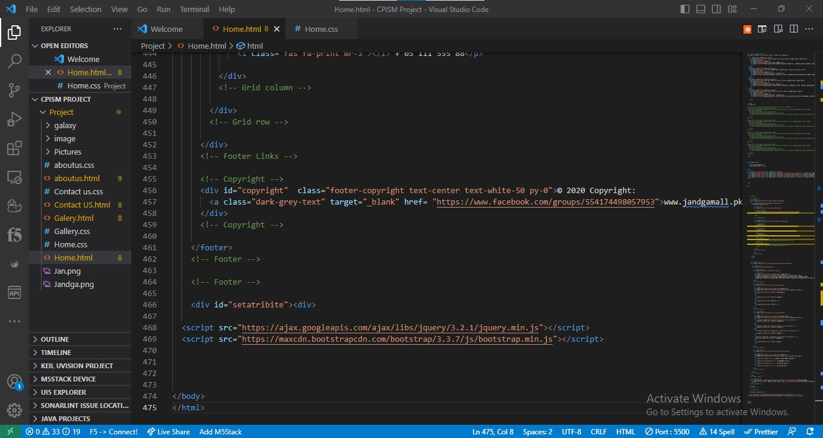

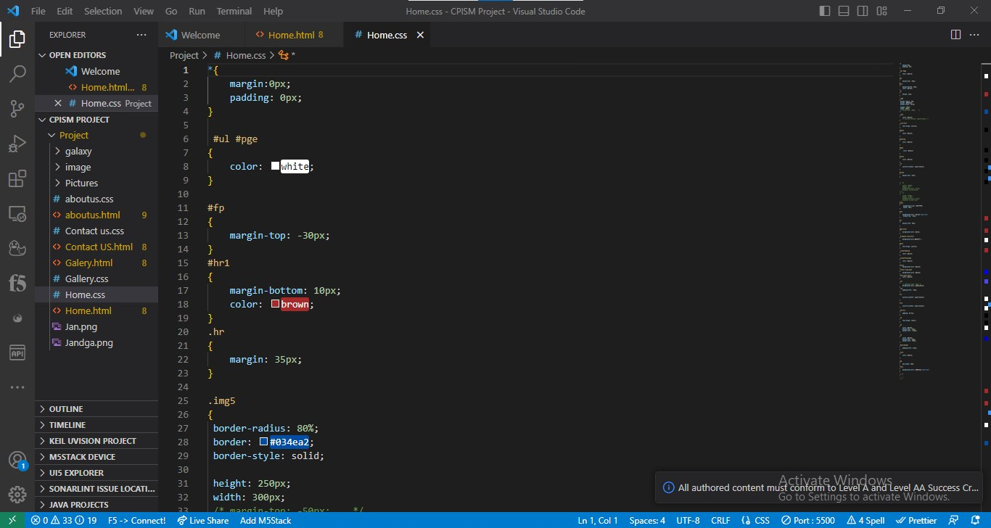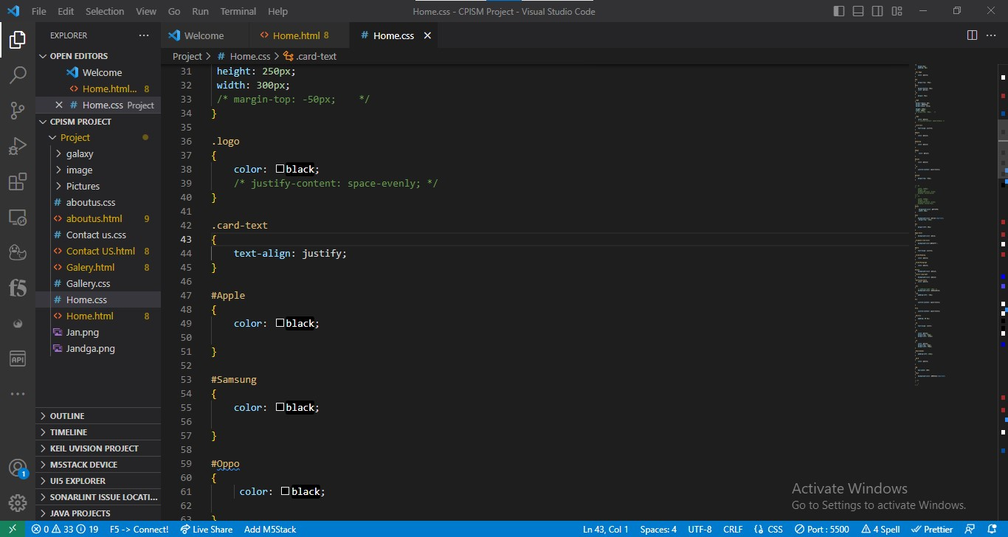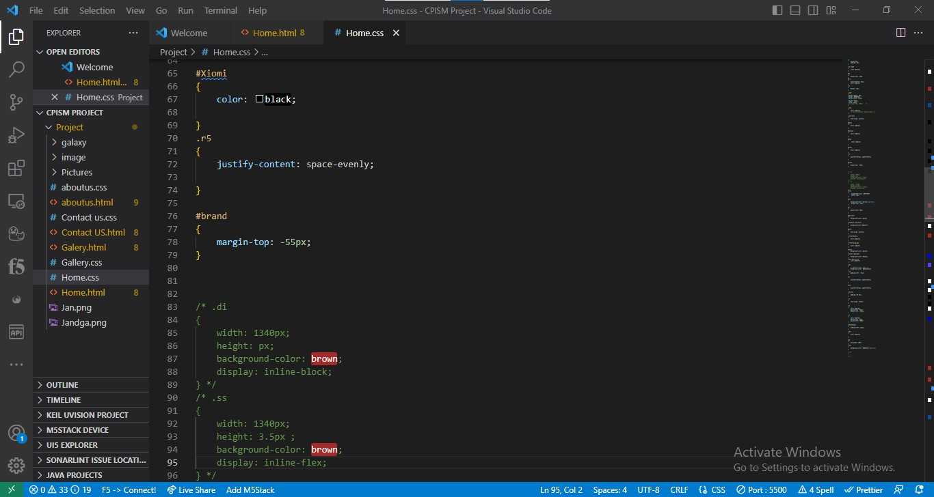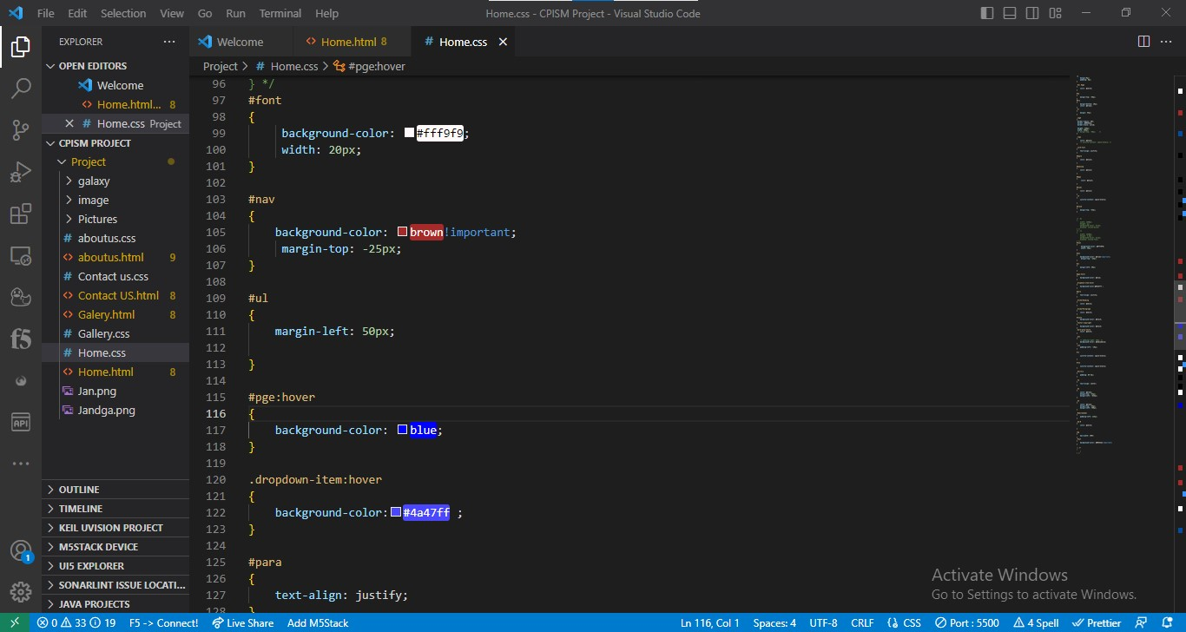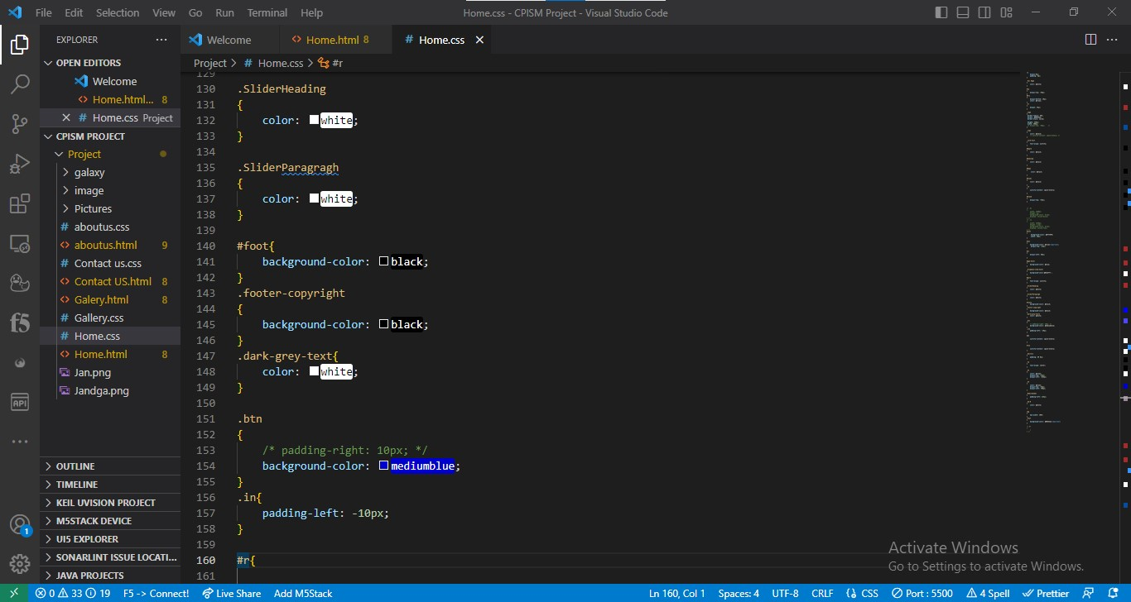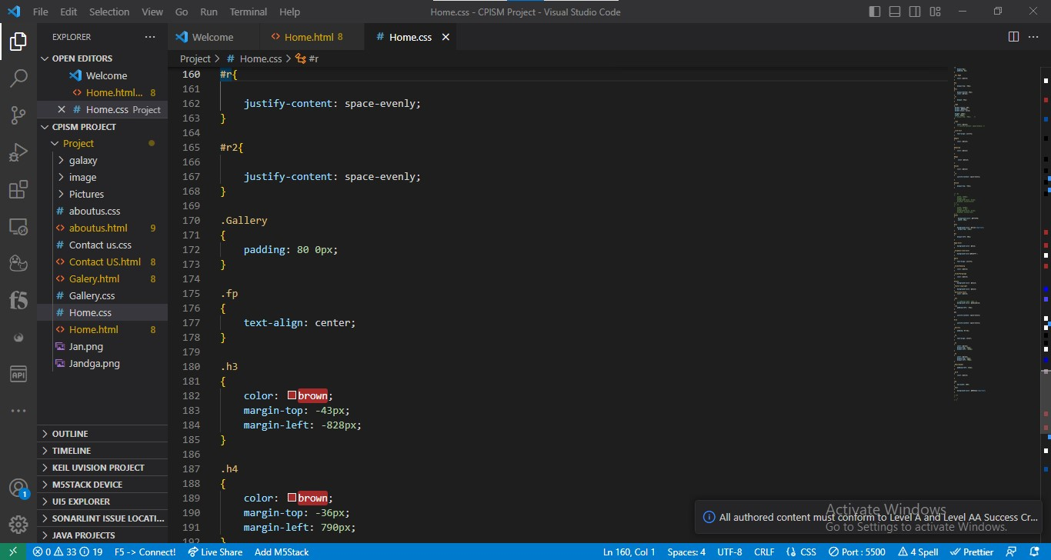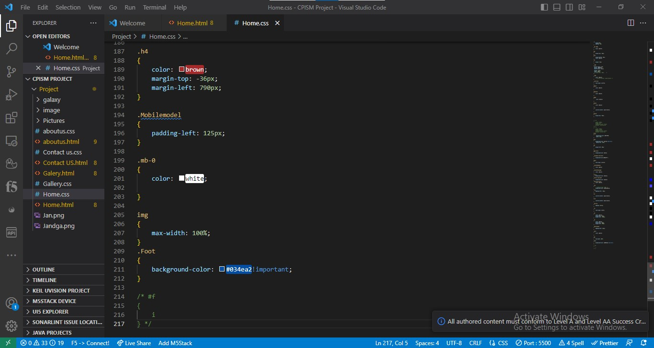

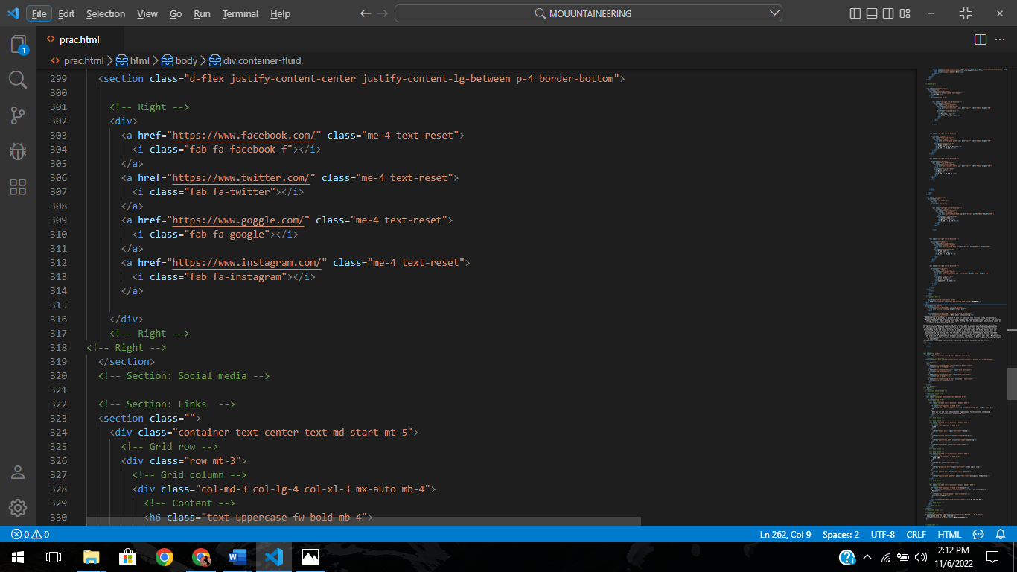



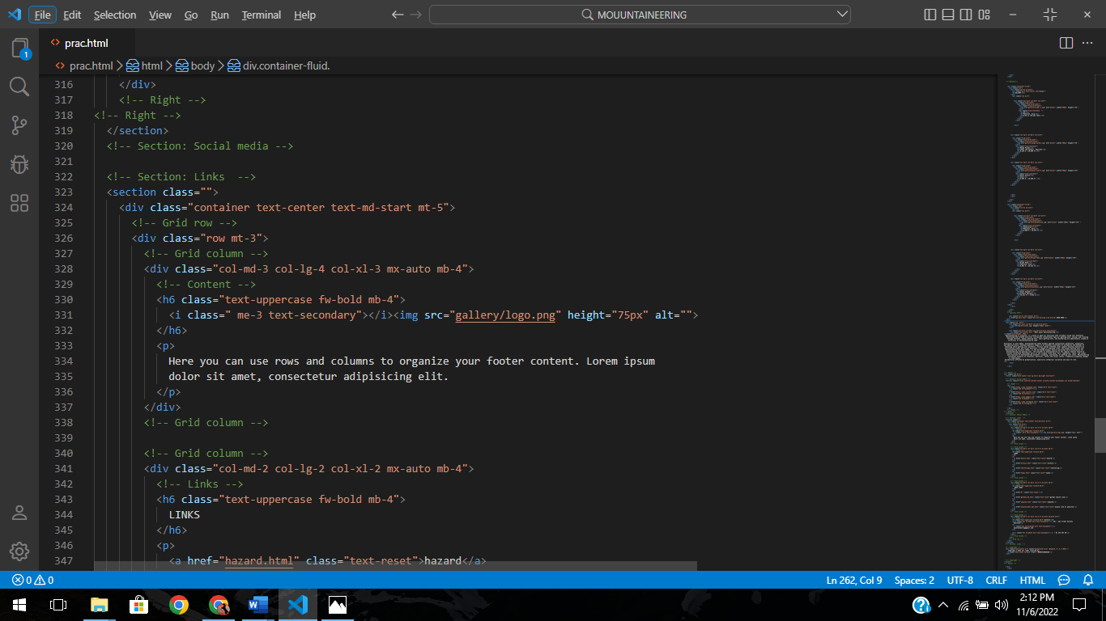

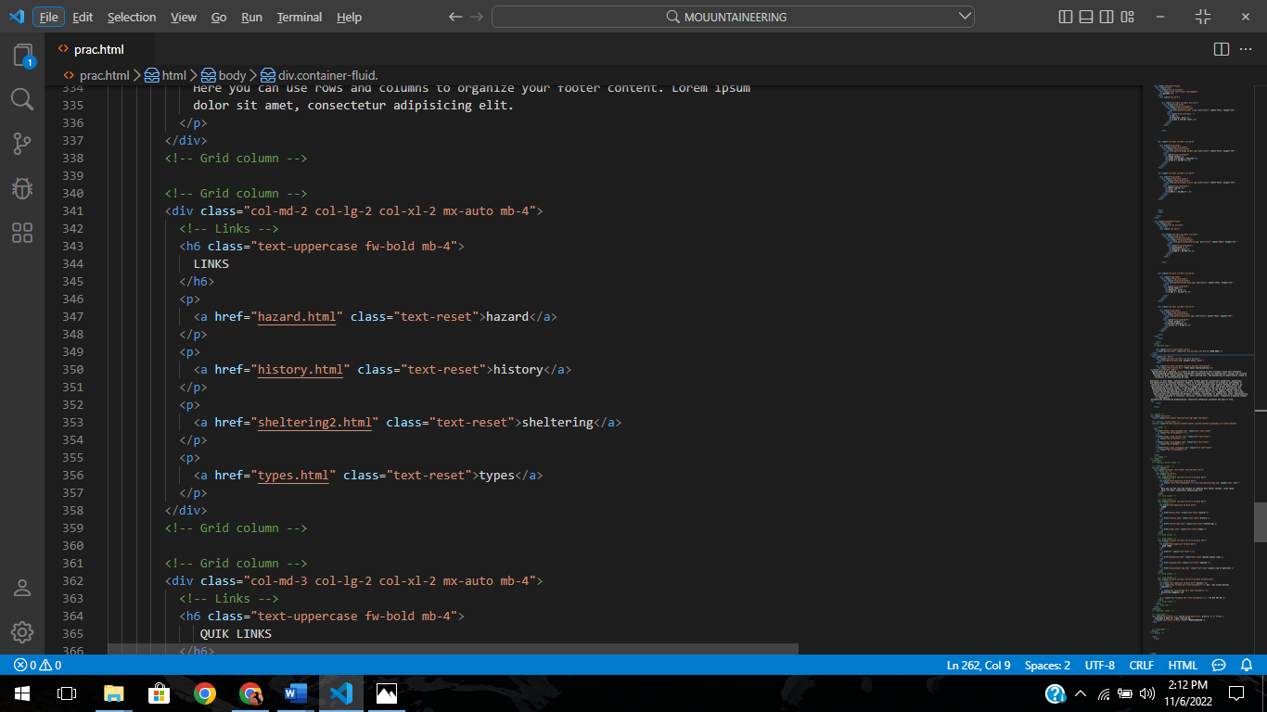

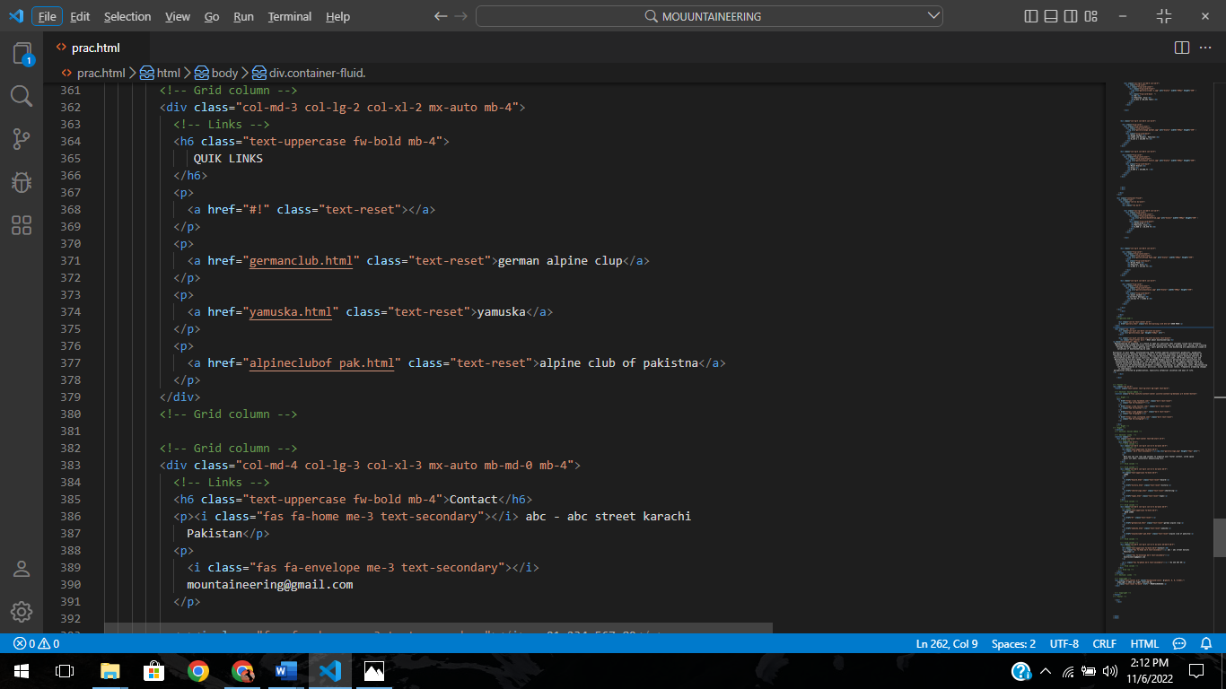

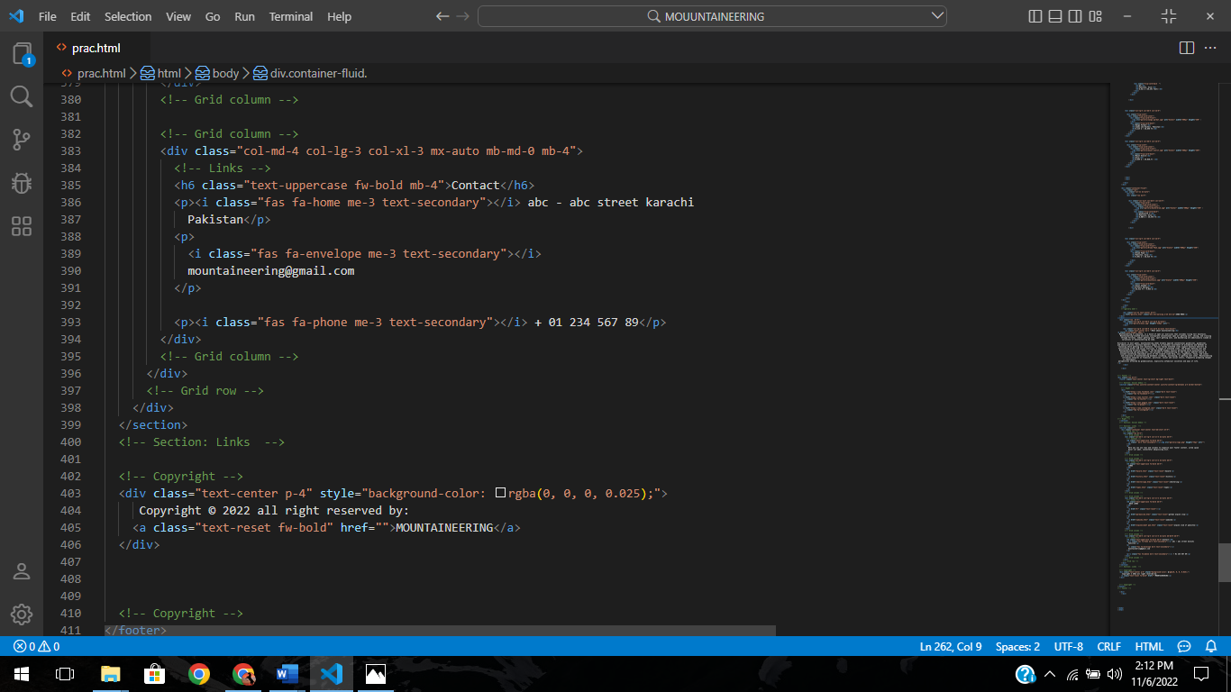

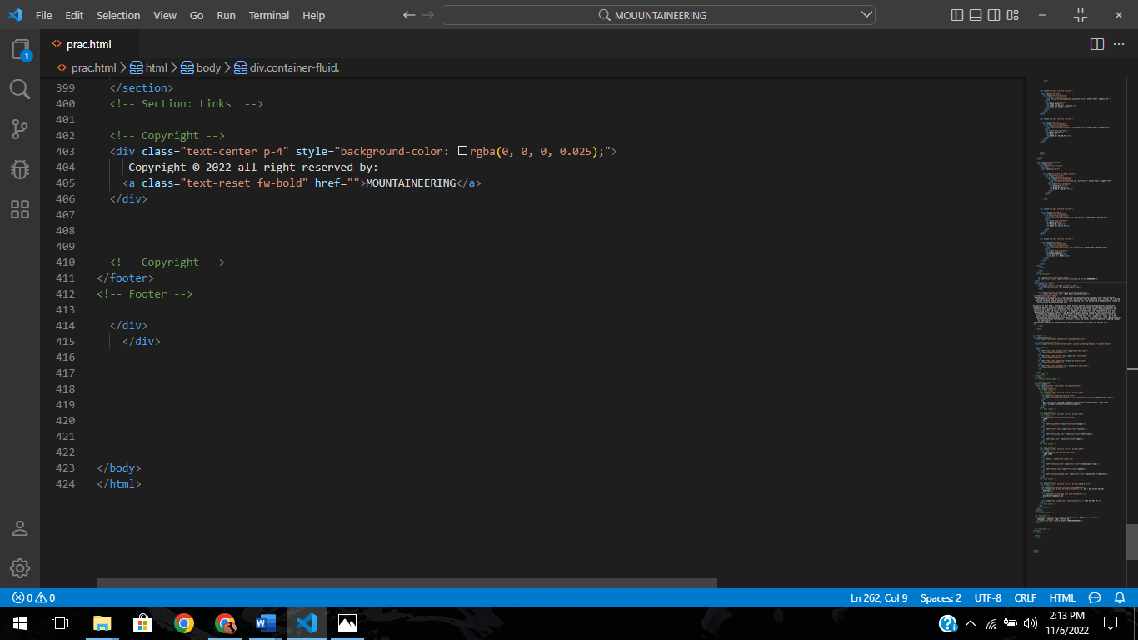

css code of home page:

